Diagnostic healthcare support chatbot?

| Fatemeh Khosravi (Ava) | 2743 9887 |
| --- | --- |
| Lachlan Muirden | 2875 9737 |
| Zaria Imran | 2777 1571 |

# Methodology

Skeleton Code Source: <https://github.com/python-engineer/pytorch-chatbot>

We have chosen to create a chatbot that is able to assist with first response healthcare, processing symptoms and giving diagnosis. The chatbot should also be aware of the likely severity of the collection of symptoms and provide recommendations based on this.

From our literature review, Kandpal et al. seemed the most basic implementation and feasible design. We have decided to use Natural Language Processing tokenizing, stemming and bag of words as described in all the literature we’ve explored. We are going to use our own model created with a Linear model with 4 hidden layers with dropout (but we would possibly increase if feasible) that fits our dataset while avoiding overfitting. If time permits, we will try to implement a model that remembers previous inputs (BRRN) such as that in Dhyani et al. Ideally we would have been able to use an XLNet and transfer learning, however this may take weeks and is probably unnecessary for our level of data.

# Dataset Description

Dataset Source: <https://www.kaggle.com/itachi9604/disease-symptom-description-dataset?select=symptom_Description.csv>

* + Symptom-severity.csv
  + dataset.csv
  + symptom_Description.csv
  + symptom_precaution.csv

This source contains 4 datasets, each of which will have utility for our chatbot. The first dataset, named ‘Symptom-severity’, contains a list of symptoms and each symptom’s associated severity, listed on a scale of one to ten. The second dataset, named ‘dataset’, contains a list of diseases and associated symptoms. The third dataset, named symptom_Description, contains a list of illnesses, and associated descriptions of each illness. The fourth dataset, named symptom_precaution, contains the same list of illnesses, but instead provides a list of precautions that can be taken if one is afflicted with each of the illnesses.

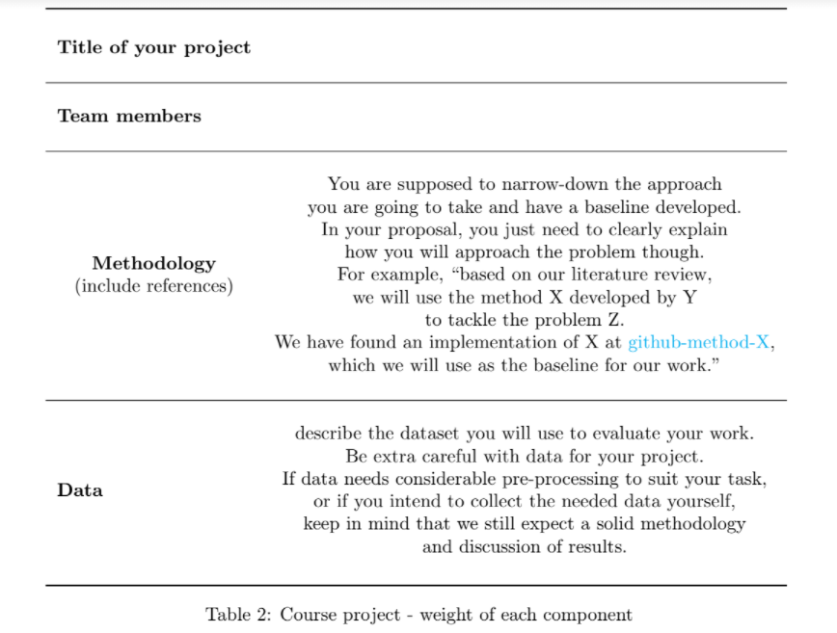

# References

* M. Dharani, J. V. S. L. Jyostna, E. Sucharitha, R. Likitha and S. Manne, "Interactive Transport Enquiry with AI Chatbot," 2020 4th International Conference on Intelligent Computing and Control Systems (ICICCS), 2020, pp. 1271-1276, doi: 10.1109/ICICCS48265.2020.9120905.
* G. K. Vamsi, A. Rasool and G. Hajela, "Chatbot: A Deep Neural Network Based Human to Machine Conversation Model," 2020 11th International Conference on Computing, Communication and Networking Technologies (ICCCNT), 2020, pp. 1-7, doi: 10.1109/ICCCNT49239.2020.9225395.
* S. P. Reddy Karri and B. Santhosh Kumar, "Deep Learning Techniques for Implementation of Chatbots," 2020 International Conference on Computer Communication and Informatics (ICCCI), 2020, pp. 1-5, doi: 10.1109/ICCCI48352.2020.9104143.
* P. Kandpal, K. Jasnani, R. Raut and S. Bhorge, "Contextual Chatbot for Healthcare Purposes (using Deep Learning)," 2020 Fourth World Conference on Smart Trends in Systems, Security and Sustainability (WorldS4), 2020, pp. 625-634, doi: 10.1109/WorldS450073.2020.9210351.
* Manyu Dhyani, Rajiv Kumar,An intelligent Chatbot using deep learning with Bidirectional RNN and attention model,Materials Today: Proceedings,Volume 34, Part 3,2021,Pages 817-824,ISSN 2214-7853,<https://doi.org/10.1016/j.matpr.2020.05.450> .

([https://www.sciencedirect.com/science/article/pii/S221478532034030X)](https://doi.org/10.1016/j.matpr.2020.05.450.(https://www.sciencedirect.com/science/article/pii/S221478532034030X)))